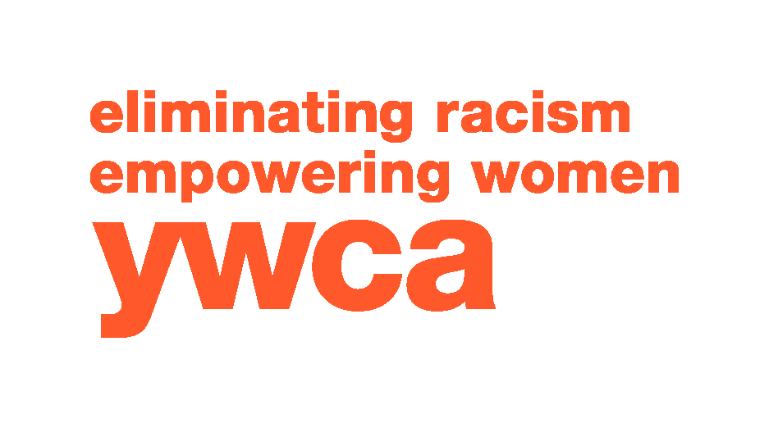

Job Title: Literacy Coordinator

Reports to: Director, YWCA Literacy Council

Job summary: Coordinate volunteer tutor training and adult reading instruction; monitor, coach, and support volunteers and group instructors. Identify, develop, and create instructional materials. Develop relationships with library representatives, community groups and agencies to promote The Literacy Council’s mission. Maintain records for reporting purposes and historical data. Coordinate learner celebrations and volunteer appreciation events.

Minimum requirements
- Bachelor’s degree in Education or related field
- Three years’ teaching experience; preferred experience teaching adults
- Training and experience in reading instruction methodologies
- Experience managing volunteers
- Ability to interact effectively with staff and program participants through verbal and written communications
- Ability to organize information and documentation, and to establish work priorities
- Technical proficiency with a personal computer and various software packages
- Excellent written, verbal, and presentation communication skills
- Obtain and document a minimum of fifteen (15) professional development hours annually
- Ability to lift 30 pounds, sit, stand, bend, and twist
- Current Illinois driver’s license and valid vehicle insurance
- Ability to work flexible schedules including evenings and weekends as needed
- Bilingual in Spanish

Preferred:
- Individual tutoring experience

Summary of essential job functions:
- Conduct intakes and reading level/performance level assessments of prospective learners to best know how to serve them.
- Schedule and conduct new tutor workshops, as well as in-services (roundtables/workshops & demonstrations of tutor materials) throughout the year.
- Pair learners with tutors for individual instruction and facilitate the initial meeting.
- Provide support to and monitor (minimum one visit/contact per year) tutor/learner pairs as needed.

- Identify, develop, and create volunteer and learner instructional materials from various resources.
- Determine and distribute appropriate assessment materials and ensure return of completed assessments from tutors by due dates.
- Transition learners who have tested out of YWCA Literacy Council programs into higher education or career pathways.
- Conduct volunteer and learner exit interviews (reason for leaving) for end of year reports for funders and other literacy agencies.
- Partner with and develop relationships with local library systems within YWCA Literacy Council’s service area to maintain onsite tutor resource materials.
- Partner with local community groups and agencies to help promote YWCA Literacy Council during local events; create opportunities for other promotional considerations.
- Provide information to tutors and learners on literacy activities, workshops, and other events through email, social media, standard mail, and website.
- Coach and encourage tutors to ensure they provide a quality experience to their learners. Work through potential challenges and present teaching techniques for individual learner needs.
- Maintain database and paper files for tutors and learners as required by funding sources.
- Assist staff in developing and coordinating volunteer projects and recognition activities, such as the annual Volunteer Appreciation Breakfast, Project WRITE-On! Celebration, and other projects as determined.
- Promote community awareness of literacy needs and services in coordination with the Program Director and appropriate staff.
- Participate in professional staff development in the field of adult education and literacy.
- Maintain tutor/learner database and provide key program information and statistics for grant writing and reporting.
- Produce quarterly newsletters material for all stakeholders.
- Organize and facilitate at least one learner book club annually, determining appropriate reading material and interactive format interactive.
- All other duties as may be assigned by the CEO.

Disclaimer
The above statements are intended to describe the general nature and level of work being performed by people assigned to this classification. They are not to be construed as an exhaustive list of all responsibilities, duties, and skills required of personnel so classified. All personnel may be required to perform duties outside of their normal responsibilities from time to time, as needed. This Job Description should not be read as creating an express or implied contract, nor is it intended to alter the employment-at-will relationship. Employment with the YWCA is "at-will" and may be terminated at any time, with or without cause, at the option of either the YWCA or the employee.

My signature below acknowledges I received a copy of this job description.

Signature_________________________________________________Date_____________

